[](http://galleryhip.com/christmas-holiday-clipart.html)Math 466

Exam Date: _____________

Midterm Topics

* Factoring
* Rational Expressions
* Properties of a function
* Linear Equations
* Analytical Geometry
* Long division
* System of equations
* Inequalities
* Polynomial Geometry

**Practice Questions Part 1**

9

To finance the year-end party, the graduating students sold agendas which brought in $3.50 in profit per book.

In addition, they sold all of the pens that the supplier gave them on the basis of one pen for every 3 agendas ordered. Each pen gave them $1.50 in profit.

How many agendas did they sell if they accumulated $3000 in profit?

10

There are 120 tennis balls in a bag : some are white, some are green and some are yellow. The number of white balls equals the number of yellow balls. If there were 20 more green balls, the number of green balls would be double the number of white balls.

How many balls of each colour are there in the bag?

15

|  |  |
| --- | --- |
| A sculpture is located at the entrance to a museum of contemporary art. The cross-section of this sculpture is represented by the diagram on the right.  The equation of the parabola is *y* = -*x*2 + 36*x* − 284.  The equation of the line associated with segment BC is  *y* = 3*x* − 24.  What is the length of segment AB? |  |

|  |  |  |  |
| --- | --- | --- | --- |
| A) | 13 units | C) | 20 units |
| B) | 15 units | D) | 36 units |

16

|  |  |
| --- | --- |
| In the Cartesian plane on the right, points A, B and C represent the location of three towns. A hiking trail connects towns A and B.  The residents of town C want to build a new trail represented by dotted line PC.  The new trail must be as short as possible. |  |

What should be the coordinates of the point of intersection P?

17

Consider square PQRS in the Cartesian plane below.

Vertex P is located on the *y*‑axis.

Diagonals PR and QS intersect at E.



What are the coordinates of point E?

18

|  |  |
| --- | --- |
| The perimeter of rectangle ABCD represented in the Cartesian plane on the right is 52 cm.  The equation associated with segment AD is 3*x* + 4*y* − 60 = 0. |  |

What is the length of segment AD?

20

Fran orders chicken wings and pizzas for herself and some friends at a restaurant. The cost of a pizza is 17 times the cost of a chicken wing.

Fran estimates that each person can eat 5 chicken wings and half a pizza. She places an order for 12 people. The total cost of this order is $64.80.

To ensure that they have enough food, Fran decides to order one more pizza.

If Fran adds one more pizza to her original order, what is the new total cost of the order?

21

|  |  |
| --- | --- |
| In the Cartesian plane on the right, a parabola and a straight line intersect at points P and Q.  The equation of the parabola is *y* = ‑*x*2 + 24*x* − 95.  The equation of the line is 4*x* − *y* − 4 = 0. |  |

What are the coordinates of points P and Q?

22

If *c* ≠ -3, what polynomial is the result of the following operation?

(2*c*3 + *c*2 − 14*c* + 3) ÷ (*c* + 3)

26

The square and the rectangle shown below are equivalent figures. Each side of the square measures (*x*) cm. The area of the rectangle is (2*x*2 − 7*x* − 30) cm2.



What is the perimeter of the rectangle?

27

|  |  |
| --- | --- |
| Points P and Q are the points of intersection of the line and the parabola drawn in the Cartesian plane on the right.  The equation of the line is *y* = 2*x* + 21.  The equation of the parabola is $y={\left(x+2\right)}^{2}+2$ . |  |

What are the coordinates of the points of intersection P and Q?

31

Points A(56, 54), B(8, 33) and C(56, 9) are the vertices of a triangle. Segment AH is an altitude of this triangle.



What is the measure of altitude AH to the nearest tenth?

**June 2014**

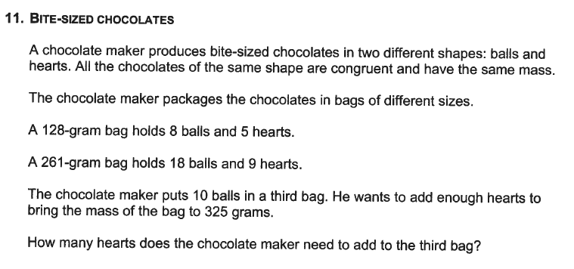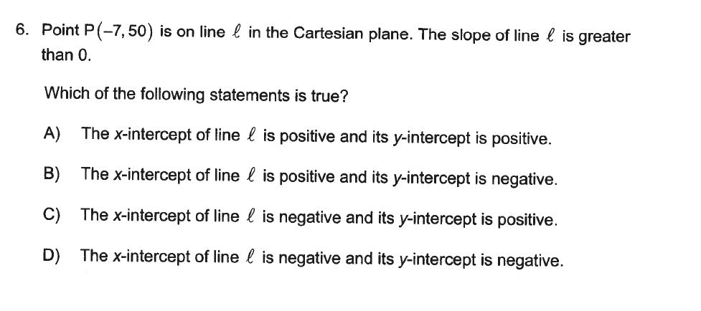

**June 2013**

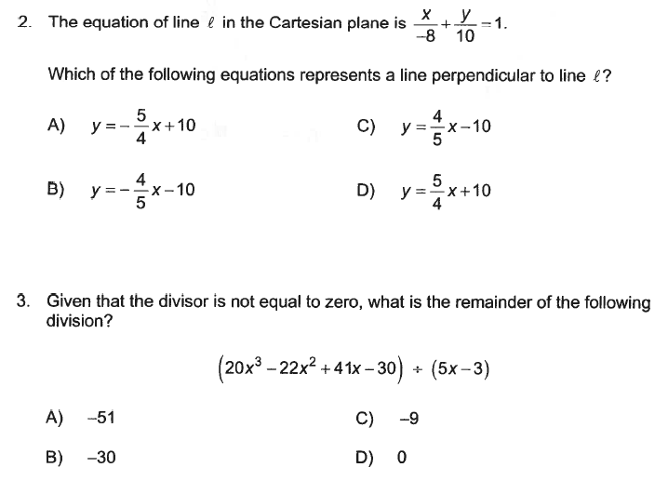

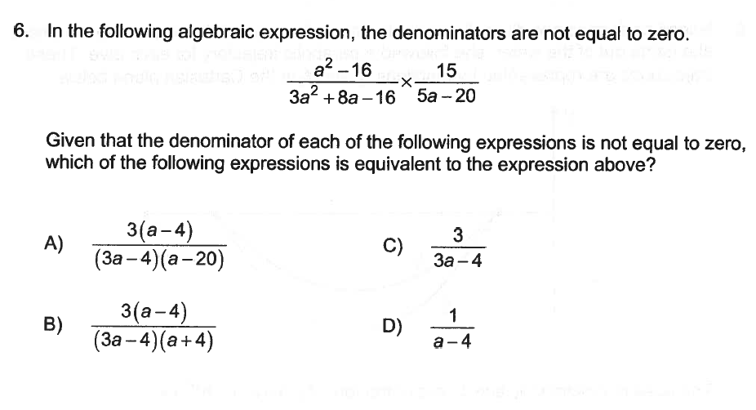

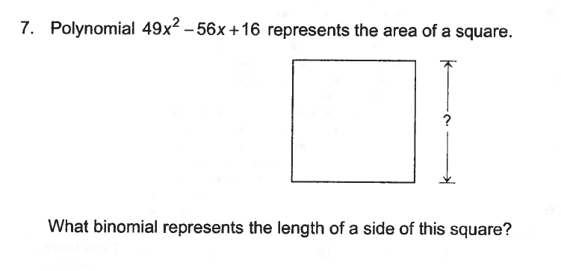

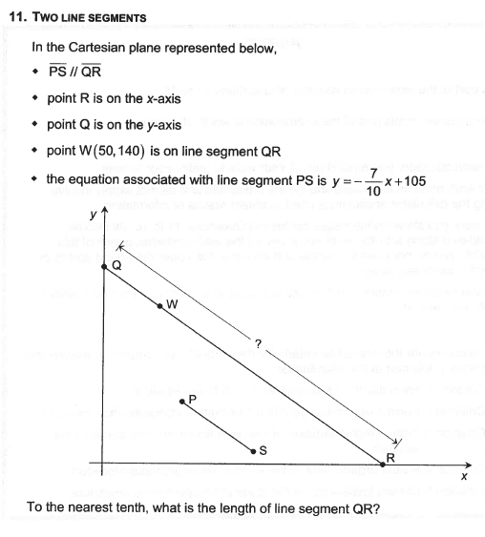

**June 2012**

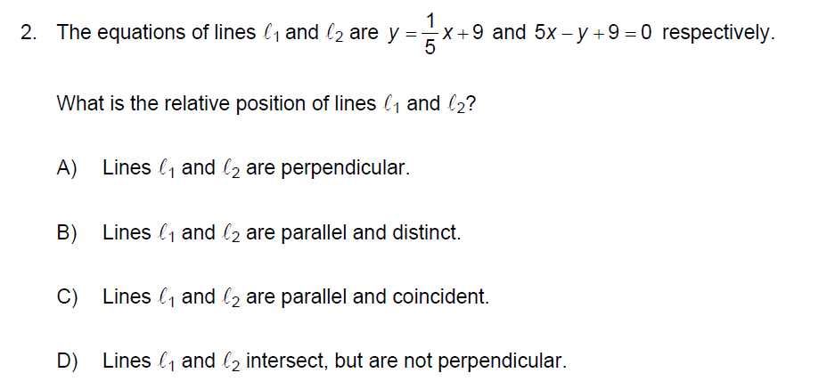

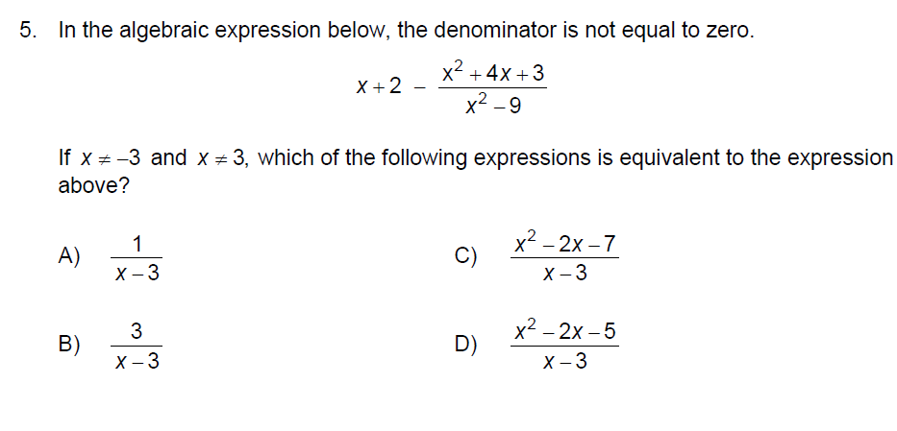

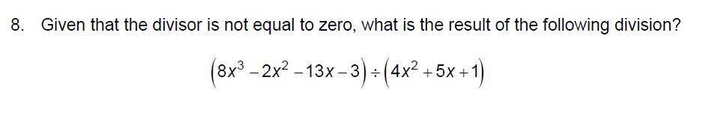

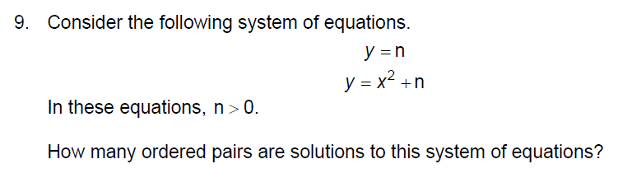

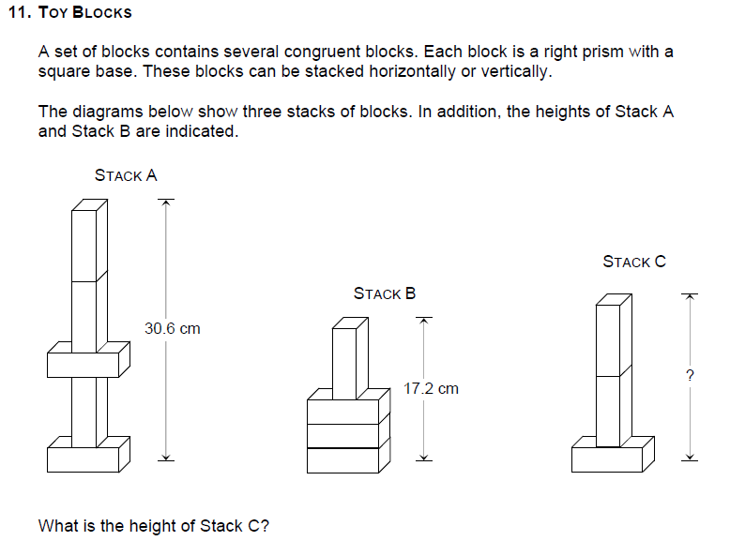

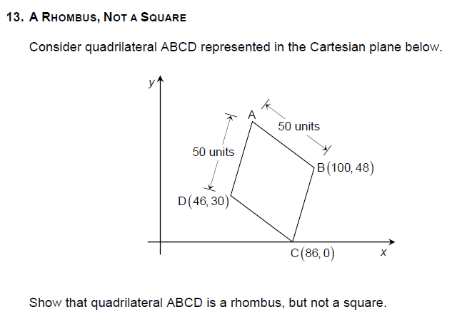

**June 2011**

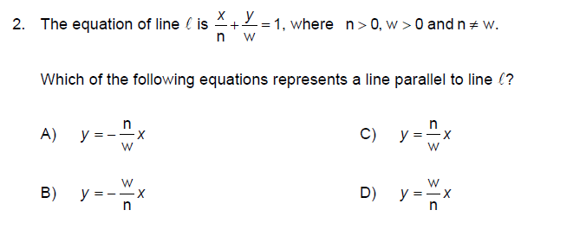

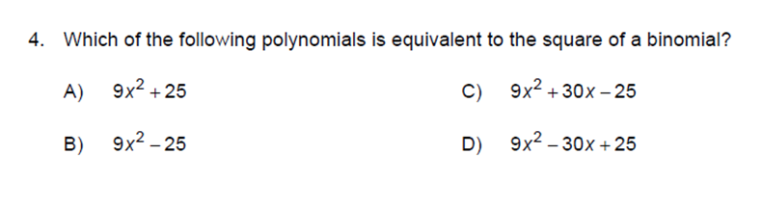

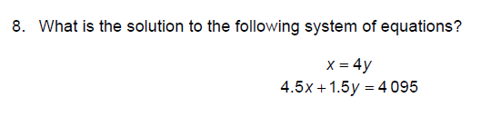

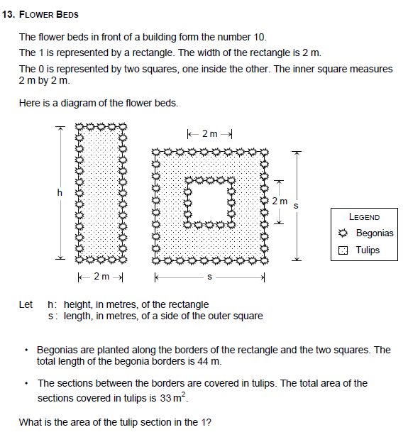

Practice Questions Part 2

2

Factor the following polynomials:

a) *ax* + *x*2 + *ay* + *xy*

b) 5*ax* + *bx* − 10*ay* − 14*by*

c) *x*4 + *x*3 + *x*2 + *x*

d) 15*xy* + 20*y*2 − 18*x* − 24*y*

e) 

3

In the figure below, the area of rectangle ABCD in square units is expressed by the trinomial 2*x*2 − 11*x* + 12, the measure of its sides being binomials.

Sides DA and DC are each extended 4 units to form a new rectangle.



In square units, what algebraic expression represents the area of the new rectangle?

|  |  |  |  |
| --- | --- | --- | --- |
| A) | 2*x*2 + 1 | C) | 2*x*2 − 11*x* + 28 |
| B) | 2*x*2 + *x* | D) | 2*x*2 + 23*x* + 56 |

4

The volume of a right prism with a rectangular base is (*x*3 + 4*x*2 + *x* − 6) m3. Its height is (*x* − 1) m.

What are the dimensions of the base of this prism?

(Express each dimension as a binomial.)

Show your work.

5

The volume of a right prism with a rectangular base is (6*x*3 − 35*x*2 + 19*x* + 30) m3. Its height is (*x* − 5) m.

What are the dimensions of the base of this prism?

(Express each dimension as a binomial.)

6

The volume of a right prism with a rectangular base is (2*x*3 + *x*2 − 22*x* + 24) m3. The area of its base is (2*x*2 + 5*x* − 12) m2.

What are the three dimensions of this prism?

(Express each dimension as a binomial.)

7

Twice in one week, a basketball team rented a minibus for transportation to its out-of-town games.

The first time, the team paid $108 in rental fees to travel 240 km and the second time, it paid $124 for 320 km.

The rental cost is represented by the equation *y* = *mx* + *b* where *x* is the number of kilometres, y is the total cost, b is the fixed base cost and m is the cost per kilometre.

What is the rate per kilometre (rate of change)?

|  |  |  |  |
| --- | --- | --- | --- |
| A) | $0.20/km | C) | $0.41/km |
| B) | $0.39/km | D) | $0.45/km |

8

In a fishing tournament on Lake Sargent, a fisherman goes from the dock at the marina towards the tip of the island. He follows a line whose equation is 2*x* − 3*y* + 17 = 0.

In the middle of his crossing, he catches a trout. At this point he changes to a direction perpendicular to the original one.



Give the equation of the line which represents the new direction.

9

Determine if the following pairs of equations represent lines which are :

‑ parallel and distinct

‑ coincident

‑ intersecting

‑ perpendicular

a) *d* : 2*x* + *y* − 3 = 0 and *d*' : 3*x* − 4*y* + 1 = 0

b) *d* : 4*x* − *y* + 3 = 0 and *d*' : *x* + 4*y* − 2 = 0

c) *d* : *x* − 2*y* + 3 = 0 and *d*' : ‑4*x* + 8*y* − 12 = 0

d) *d* : 3*x* − 4*y* + 1 = 0 and *d*' : 6*x* − 8*y* − 9 = 0

e) *d* : *y* + 5 = 0 and *d*' : *x* − 3 = 0

11

The northern side AB of the roof of a cottage is reinforced by a brace CD which is perpendicular to it.

The slope of this side is .



Which of the following equations represents a line parallel to the brace?

|  |  |  |  |
| --- | --- | --- | --- |
| A) | 6*x* − 4*y* + 1 = 0 | C) | 2*x* + 3*y* − 2 = 0 |
| B) | 3*x* + 2*y* + 4 = 0 | D) | 2*x* + 3*y* − 6 = 0 |

12

An experiment consists of mixing two liquids and observing the change in temperature of the mixture. The results are presented in the table below.

|  |  |
| --- | --- |
| Time elapsed  (in minutes) | Temperature  (in °C) |
| 2  4  7  10 | 26.9  31.5  38.4  45.3 |

The phenomenon can be expressed by a linear function which associates the temperature f(*t*) of the mixture with the elapsed time *t*.

What equation represents this function?

17

The following graph shows the change in the number of litres of oil in a tank over an 11‑hour period.



According to this graph, which statement is true?

|  |  |
| --- | --- |
| A) | The rate of change between points P and R is positive. |
| B) | The rate of change between points R and S is negative. |
| C) | The rate of change between points N and P is the same as the rate of change between points S and T. |
| D) | The rate of change between points M and N is different from the rate of change between points R and S. |

18

In a Cartesian plane, line segment AB passes through points A(2, 4) and B(8, 16). Line *l* is perpendicular to this segment and passes through point C(4, 8).

What is the equation of line *l*?

23

A kitchen faucet leaks. The graph below illustrates the number of litres of water lost as a function of the time in hours.



If nobody repairs the faucet, how many litres of water will be lost in 7 days?

24

A swimming pool containing 30 000 litres of water is emptied by means of a pump which pumps water at a constant rate.

The pump is turned on at 8:00 a.m. By noon there are still 22 000 litres of water in the pool.

At this rate, at what time will the pool be completely empty?

28

A oil company decides to fill up a large reservoir with heating oil to store its winter supply.

At the start of the operation, there were 400 000 litres in the reservoir. They then filled the reservoir at a rate of 50 000 litres of oil per hour.

Calculate the number of litres in the reservoir after 8 hours.

|  |  |  |  |
| --- | --- | --- | --- |
| A) | 400 000 litres | C) | 800 000 litres |
| B) | 450 000 litres | D) | 3 600 000 litres |

29

Two video clubs rent cassettes. Club A charges $5 for a membership card and then $2 for the rental of each cassette. Club B charges $10 for a membership card and then $1.80 for the rental of each cassette.

There is a specific number of cassettes for which it is no more advantageous to belong to Club A than Club B.

What is that number of cassettes?

Show all your work.

30

For a ride in a taxi, $2.10 is charged as a basic rate and $0.50 is charged for each kilometre travelled.

If you are charged $10.40 for ride, what distance, in kilometres, did you travel?

31

An old-fashioned sand timer contains 225 mL of sand. The sand flows from the top to the bottom at a rate of 9 mL per second.

Which one of the following graphs shows the amount of sand in the bottom of the timer as a function of time?

|  |  |  |  |
| --- | --- | --- | --- |
| A) |  | C) |  |
| B) |  | D) |  |

35

During the Christmas holidays, Pierre shovelled the walkways of a small shopping mall with a snow shovel. He earned $6.50 per hour for the work, but he had to spend $17 for various expenses.

This situation can be represented by a function which gives the net income p(*n*) as a function of the number of hours (*n*) of work.

How many hours did Pierre have to work to earn $100?

|  |  |  |  |
| --- | --- | --- | --- |
| A) | 18 hours | C) | 15 hours |
| B) | 17 hours | D) | 12 hours |

39

|  |  |
| --- | --- |
| The adjacent graph represents the body temperature of each of two animals as a function of the external temperature. |  |

According to the graph above, which of the following statements is true?

1. The dog's temperature is constant.

2. The dog's temperature is always equal to the external temperature.

3. The snake's temperature is constant.

4. The snake's temperature is equal to the external temperature.

|  |  |  |  |
| --- | --- | --- | --- |
| A) | 1 and 3 | C) | 2 and 3 |
| B) | 1 and 4 | D) | 2 and 4 |

45

In a particular city, a taxi ride costs $2.00 plus a certain amount for each kilometre travelled. Allen paid $18.00 for a 20 km ride. How much will Melanie have to pay for a 5 km ride?

|  |  |  |  |
| --- | --- | --- | --- |
| A) | $6.25 | C) | $4.50 |
| B) | $6.00 | D) | $4.00 |

62

The following Cartesian graph represents a function.



On which interval is this function increasing?

|  |  |  |  |
| --- | --- | --- | --- |
| A) | [0, 6] | C) | [6, 16] |
| B) | [0, 10] | D) | [10, 16] |

63

Simplify the following algebraic expression.



66

In the following algebraic expression, the denominators are not equal to zero.



Which of the following expressions is equivalent to this algebraic expression?

|  |  |  |  |
| --- | --- | --- | --- |
| A) |  | C) |  |
| B) | *x* + 3 | D) |  |

68

The following are some of the characteristics of a polynomial function *f*:

• this function is represented by a straight line in the Cartesian plane

• *f*(-5) = 67

• *f*(2) = -10

What is the rule of this function *f*?

69

In the following diagram, quadrilaterals ABCD and FBGH are rectangles. In addition,  = 6 units and  = 6 units.



The polynomial 12*x*2 + 28*x* − 5 represents the area of rectangle ABCD.

What polynomial represents the area of rectangle FBGH?

71

In the figure below, line segment PQ divides rectangle ABCD into the following two quadrilaterals: square APQD and rectangle PBCQ.

The area of rectangle ABCD is 120 cm2. In addition,  = (*x*) cm and  = (*x* + 8) cm.



What is the numerical area of rectangle PBCQ?

CORRECTIONS TO PRACTICE QUESTIONS PART 1

9

750 agendas.

10

Work : (example)

Let *x* : represent the number of white balls

*y* : represent the number of green balls

*x* : represent the number of yellow balls

The system of equations

2*x* + *y* = 120

*y* + 20 = 2*x*

Solution of the system of equations

|  |  |
| --- | --- |
| 2*x* + *y* =  2*x* − *y* =  4*x* =  *x* = | 120  20  140  35 and *y* = 50 |

Result : The number of white and yellow balls is 35 each and the number of green balls is 50.

15

D

16

Example of an appropriate solution

If they are to minimize the length of the new trail, they must make the two trails perpendicular to each other.

Slope of segment AB: 

Equation of the line representing trail AB: *y* = *x* + 30

Slope of new segment: 

Equation of the line representing the new trail

*y* = *x* + b

17 =  (40) + b

1 = b

*y* = *x* + 1

Coordinates of the point of intersection

This system of equations must be solved *y* = *x* + 1 and *y* = *x* + 30

*x* + 1 = *x* + 30

*x* = 29

*x =* 10

*y* = 5

Answer The coordinates of the point of intersection P should be (10, 5).

17

Example of an appropriate method

Slope of segment QR



Slope of segment PQ

The product of the slopes of two perpendicular segments is equal to -1.

Slope of segment PQ × slope of segment QR = -1

Slope of segment PQ × -2 = -1

Slope of segment PQ: 

Coordinate of point P

*y*‑intercept of segment PQ



Coordinates of point P: P(0, 38)

Coordinates of point E

Since the diagonals of a square bisect each other, point E is the midpoint of segment PR.



Answer: The coordinates of point E are E(**27, 29**).

**Note:** Students who use an appropriate method in order to determine the coordinates of point P have shown that they have a partial understanding of the problem.

18

Example of an appropriate method

Length of segment CD

The length of segment CD is equal to the distance between vertex C and segment AD.



Length of segment CD

10 cm

Length of segment AD

Perimeter of the rectangle



Length of segment AD

16 cm

Answer: The length of segment AD is **16** cm.

**Note:** Students who use an appropriate method in order to determine the length of segment CD have shown that they have a partial understanding of the problem.

20

Example of an appropriate method

System of equations representing the situation

*x*: cost of one chicken wing, in dollars

*y*: cost of one pizza, in dollars

|  |  |  |
| --- | --- | --- |
|  | ⇒ |  |

Solving the system of equations



Since *x* = 0.40,



Cost of the order with one more pizza

Cost of the order + Cost of a pizza

$64.80 + $6.80

$71.60

Answer: If Fran adds one more pizza to her original order, the new total cost of the order is $**71.60**.

**Note:** Students who use an appropriate system of equations in order to represent the situation have shown that they have a partial understanding of the problem.

Written information is considered unclear if students do not correctly define the variables they used in their solution.

21

The coordinates of points P and Q are P(**7, 24**) and Q(**13, 48**).

22

Polynomial **2*c*2 − 5*c* + 1** is the result of this operation.

26

Example of an appropriate method

Value of *x*

Since the square and the rectangle are equivalent, their areas are equal.

Area of the rectangle = Area of the square

2*x*2 − 7*x* − 30 = *x*2

*x*2 − 7*x* − 30 = 0

*x*2 − 10*x* + 3*x* − 30 = 0

*x*(*x* − 10) + 3(*x* − 10) = 0

(*x* − 10)(*x* + 3) = 0

*x* = 10 or *x* = -3 (impossible)

Algebraic expressions representing the dimensions of the rectangle

2*x*2 − 7*x* − 30

2*x*2 − 12*x* + 5*x* − 30

2*x*(*x* − 6) + 5(*x* − 6)

(*x* − 6)(2*x* + 5)

The rectangle measures (*x* − 6) cm by (2*x* + 5) cm.

Perimeter of the rectangle

Since *x* = 10, the rectangle measures 4 cm by 25 cm.

Perimeter: 2(4 + 25) = 58 cm

Answer: The perimeter of the rectangle is **58** cm.

**Note:** Students who use an appropriate method in order to determine the value of *x* **or** the algebraic expressions representing the dimensions of the rectangle have shown that they have a partial understanding of the problem.

27

Example of an appropriate method

*y* = (*x* + 2)2 + 2 or *y* = *x*2 + 4*x* + 6

Points of intersection of the line and the parabola

*x*2 + 4*x* + 6 = 2*x* + 21

*x*2 + 2*x* − 15 = 0

(*x* + 5)(*x* − 3) = 0

*x* = -5 or *x* = 3

If *x* = -5 then *y* = 2(-5) + 21 = 11

If *x* = 3 then *y* = 2(3) + 21 = 27

Answer: The coordinates of the points of intersection are P(-**5, 11**) and Q(**3, 27**).

**Note:** Students who use an appropriate method in order to determine the equation of the parabola have shown that they have a partial understanding of the problem.

31

Example of an appropriate method

**Equation of the line passing through B and C**

Slope: 

*y* = -0.5*x* + b

33 = -0.5(8) + b

37 = b

*y* = -0.5*x* + 37

**Measure of altitude AH**

 = distance between A and the line passing through B and C



Answer The measure of altitude AH to the nearest tenth is 40.2 units.

**Note** Do not penalize students who did not round off their final answer or who made a mistake in rounding it off.

Students who correctly or incorrectly determine the equation of the line passing through B and C have shown that they have a partial understanding of the problem.

The following are the steps in another appropriate method:

⏵ 

⏵ 

⏵ 

⏵ m ∠ACB using the law of cosines

⏵  using the sine ratio

In this case, students who correctly or incorrectly determine the measure of angle ACB have shown that they have a partial understanding of the problem.

**CORRECTIONS TO JUNE EXAMS**

**JUNE 2014**

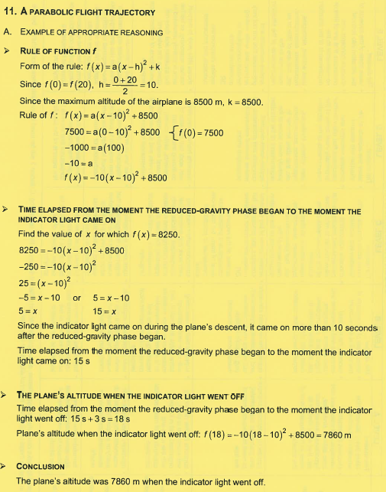**6.) C**

**11.)**

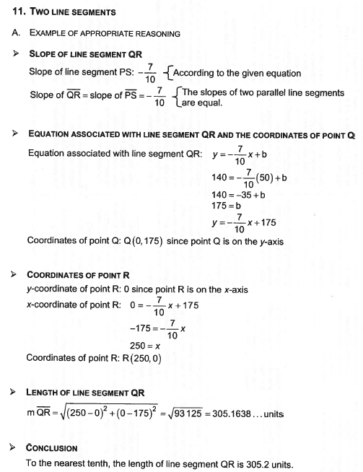**JUNE 2013**

**2.) B**

**3.) C**

**6.) C**

**7.) 7x - 4**

**11.) 🡪**

**JUNE 2012**

**2.) D**

**5.) C**

**8.) 2x - 3**

**9.) only one**

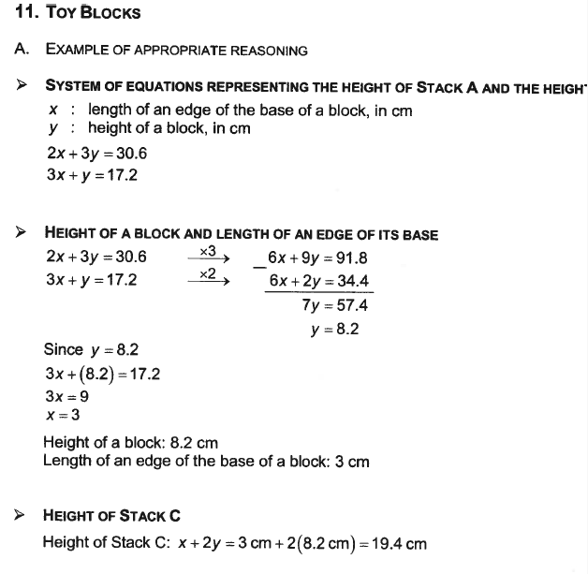**11.)**

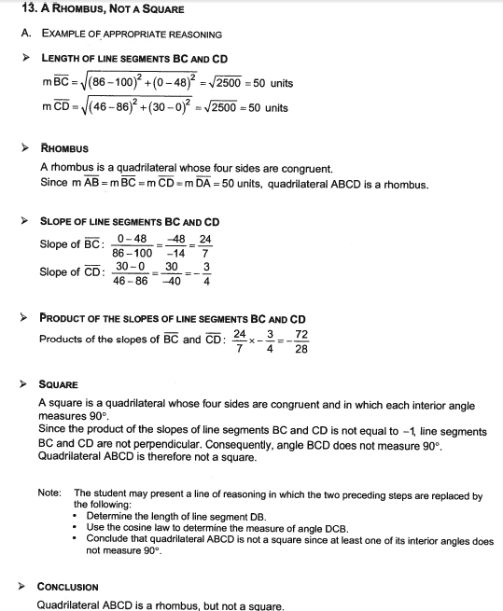**13.)**

**JUNE 2011**

**2.) B**

**4.) D**

**8.) x = 840, y= 210**

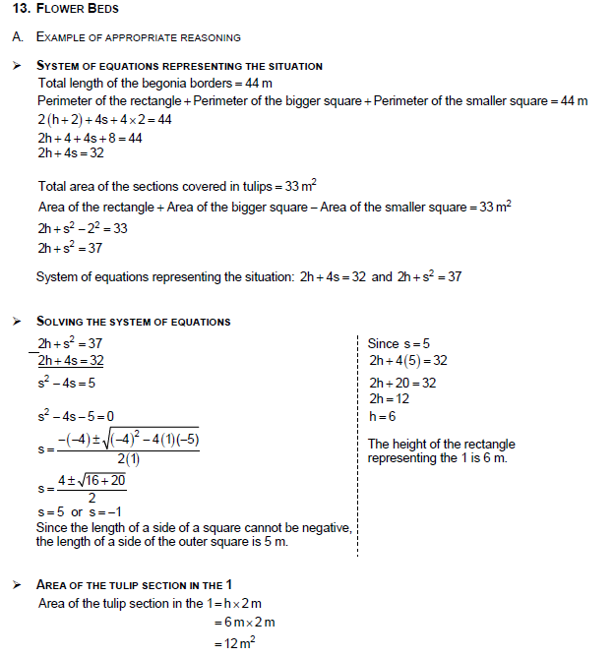**13.)**

CORRECTIONS PRACTICE QUESTIONS PART 2

2

a) (*a* + *x*) (*x* + *y*)

b) (5*a* + 7*b*) (*x* − 2*y*)

c) *x*(*x* + 1) (*x*2 + 1)

d) (3*x* + 4*y*) (5*y* − 6)

e) 

3

B

4

Example of an appropriate method

Area of the rectangular base of the right prism

Volume = area of the base × height

Area of the base = 

Area of the base = *x*2 + 5*x* + 6

Dimensions of the rectangular base of the right prism

Area = length × width

*x*2 + 5*x* + 6 = (*x* + 3)(*x* + 2)

Result The dimensions are (*x* + 3) m and (*x* + 2) m.

5

Work : (example)

Area of the rectangular base of the right prism

Volume = area of the base × height

Area of the base = 

Area of the base = (6*x*2 − 5*x* − 6) m2

Dimensions of the rectangular base of the right prism

Area = length × width

6*x*2 − 5*x* − 6 = (3*x* + 2)(2*x* − 3)

Result The dimensions are (3*x* + 2) m and (2*x* − 3) m.

6

Work : (example)

Height of the right prism with a rectangular base

Volume = Area of the base × height

Height = 

Height = *x* − 2

Dimensions of the rectangular base of the right prism

Area = length × width

2*x*2 + 5*x* − 12 = (2*x* − 3)(*x* + 4)

Result The dimensions of the base are (2*x* − 3) m and (*x* + 4) m and the height is (*x* − 2) m.

7

A

8

Work : (example)

Mid‑point of the line segment joining the dock to the tip of the island.



Slope of this line segment.



Slope of the line perpendicular to the line segment whose slope is .

m1m2 = -1 where m1 = 

from which m2 = -

Equation of the line whose slope is - and which passes through point (2.7).



3*x* + 2*y* − 20 = 0

Result 3*x* + 2*y* − 20 = 0 or an equivalent equation.

9

a) Intersecting b) Perpendicular c) Coincident

d) Parallel distinct e) Perpendicular

11

A

12

The equation that represents the function is f(*t*) = 2.3*t* + 22.3

or any other equivalent equation.

|  |  |
| --- | --- |
| Examples : *y* =  *y* =  f(*x*) = | 2.3*x* + 22.3  2.3*t* + 22.3  2.3*x* + 22.3 |

17

C

18

Work : (example)

Slope of segment AB(*m*1)

|  |  |
| --- | --- |
| *m*1 = |  |
| *m*1 = |  |
| *m*1 = | 2 |

Slope of line *l*(*m*2)

|  |  |
| --- | --- |
| *m*2 = | (Line *l* is perpendicular to .) |
| *m*2 = |  |

Equation of line l

|  |  |
| --- | --- |
| = |  |
| 2*y* − 16 = | -*x* + 4 |
| *x* + 2*y* − 20 = | 0 |

Result The equation of line *l* is *x* + 2*y* − 20 = 0.

Note : Accept an equivalent equation.

23

The faucet will lose 84 litres in 7 days.

24

Work : (example)

Pump rate

 = 2000 L/h

Time required to empty the 22 000 litres remaining

 = 11 h

Time when the pool will be empty.

12:00 + 11:00 = 23:00

Any other complete and acceptable work with the correct result.

Other correct answers: 11:00 p.m., 11:00 at night

28

C

29

Work (example)

The equations defining the rental costs at Clubs A and B

Club A : C(*x*) = 5 + 2*x*

Club B : C(*x*) = 10 + 1.80*x*

Number of cassettes rented for the rental charges at Club A to be equal to those at Club B

|  |  |
| --- | --- |
| 5 + 2*x* =  0.20*x* =  *x* = | 10 + 1.80*x*  5  25 |

Result the number of cassettes is 25.

30

Work : (example)

|  |  |
| --- | --- |
| Given *d* :  C(*d*) : | distance travelled in km  cost for a taxi ride |

This situation can be represented by the function

C(*d*) = 0.50*d* + 2.10

If C(*d*) = 10.40, then

|  |  |
| --- | --- |
| 10.40 =  8.30 =  16.6 = | 0.50*d* + 2.10  0.50*d*  *d* |

Result The distance travelled was 16.6 km.

31

B

35

A

39

B

45

B

62

B

63

The result is 3*a*

66

C

68

The rule of this function *f* is *f*(*x*) = -11*x* + 12.

**Note:** Give two marks if the rate of change is correct, but the *y*-intercept is incorrect.

69

Example of an appropriate method

Lengths of the sides of rectangle ABCD

Area: 12*x*2 + 28*x* − 5

12*x*2 + 30*x* − 2*x* − 5

6*x*(2*x* + 5) − 1(2*x* + 5)

(2*x* + 5)(6*x* − 1)

Rectangle ABCD measures (2*x* + 5) units by (6*x* − 1) units.

Lengths of the sides of rectangle FBGH

2*x* + 5 − 6 = 2*x* − 1

6*x* − 1 − 6 = 6*x* − 7

Rectangle FBGH measures (2*x* − 1) units by (6*x* − 7) units.

Area of rectangle FBGH

Area: (2*x* − 1)(6*x* − 7)

12*x*2 − 14*x* − 6*x* + 7

12*x*2 − 20*x* + 7

Answer: The polynomial 12*x*2 − 20*x* + 7 represents the area of rectangle FBGH.

**Note**: Students who use an appropriate method in order to determine the binomials representing the lengths of the sides of rectangle ABCD have shown that they have a partial understanding of the problem.

71

Example of an appropriate method

**Polynomial representing the area of rectangle ABCD**

Since APQD is a square, segment AD measures (*x*) cm.

Area of rectangle ABCD









2*x*2 + 8*x*

Value of *x*

Area of rectangle ABCD = 120 cm2

|  |  |
| --- | --- |
| 2*x*2 + 8*x* = | 120 |
| 2*x*2 + 8*x* − 120 = | 0 |
| 2(*x*2 + 4*x* − 60) = | 0 |
| *x*2 + 4*x* − 60 = | 0 |
| *x*2 − 6*x* + 10*x* − 60 = | 0 |
| *x*(*x* − 6) + 10(*x* − 6) = | 0 |
| (*x* − 6)(*x* + 10) = | 0 |
| *x* = | 6 or *x* = −10 (impossible) |

Area of rectangle PBCQ



*x*(*x* + 8)

6(6 + 8)

84 cm2

Answer: The numerical area of rectangle PBCQ is **84** cm2.

**Note:** Students who use an appropriate method in order to determine the polynomial representing the area of rectangle ABCD **and** then write the equation 2*x*2 + 8*x* = 120 have shown that they have a partial understanding of the problem.